**PIR(passive infrared sensor) Motion Detector**

**Description**: In this project, we will make a PIR(**passive infrared sensor**) motion sensor which detect the motion of an object.

**Hardware requirement**:

* Arduino uno board
* Breadboard
* Jumper wire
* PIR motion detector sensor
* A LED light/Buzzer

**PIR Sensor:**

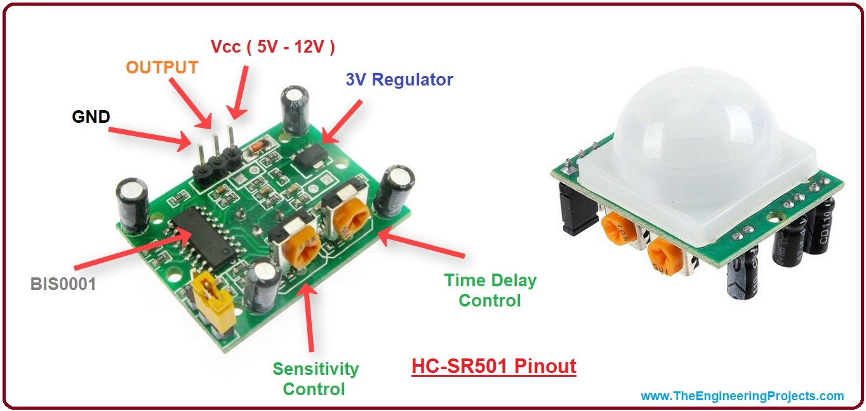

**Connection**:

* PIR’s output terminal connected to Arduino’s pin:4
* LED’s anode terminal connected to Arduino’s pin:8

**CIRCUIT**:

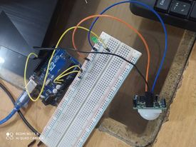

**After closing hands To the projects:**

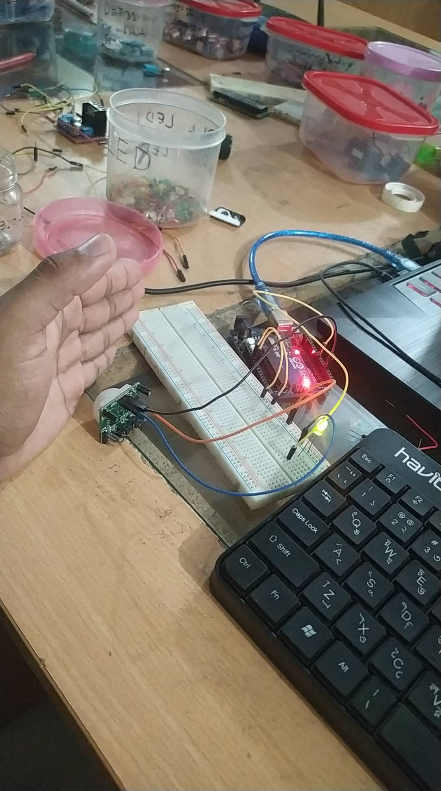

**Code**:

|  |
| --- |
| int pir=4;  int buzzer=8;  void setup() {  // put your setup code here, to run once:  pinMode(pir,INPUT);  pinMode(buzzer,OUTPUT);  Serial.begin(9600);  }  void loop() {  // put your main code here, to run repeatedly:  int state;  state= digitalRead(pir);  digitalWrite(buzzer,state);  Serial.println(state);  delay(1000);  } |